Unit 3 Packet c. 600 – 1450

Timeline
Dates (all dates in CE) | Event | Location(s)
330 – 1453 | - Byzantine Empire (extension of Roman empire) | Europe
c. 900 | - Decline of classical Maya | Modern-day Mexico
610  632 | - Start of Islam  - Death of Muhammad, rise of caliphs | Mecca (Middle East)  Medina (Middle East)
661 – 750  732 | - Umayyad Caliphate  - Battle of Tours | Middle East  Modern-day France
c. 730 | - Printing invented | China
750 – 1258 | - Abbasid Caliphate | Middle East
800s – 1100s | - Vikings travel around Europe and to North America | Europe to North America
1054 | - Schism of 1054 (East-West Schism) | Europe (Constantinople and Rome)
1071 | - Battle of Manzikert | Anatolia
1095 | - 1st Crusade | Europe to Middle East
1100 – 1533 | - Inca civilization | South America
1206 – c. 1370  1258 | - Mongol Empire  - Mongols sack Baghdad, end of Abbasid caliphate | East Asia to Middle East
1271 – 1295 | - Travels of Marco Polo | Europe to East Asia
1279 – 1368 | - Yuan (Mongol) Dynasty | China
1299 | - Start of Ottoman Empire | Modern-day Turkey
1324 | - Travels of Mansa Musa | North Africa
1325 – 1349 | - Travels of Ibn Battuta | North Africa
1325 – 1521 | - Aztec civilization | Mesoamerica
1347 – 1352 | - Bubonic Plague sweeps through Europe | Europe
1368 – 1644 | - Ming Dynasty | China
1405 – 1433 | - Travels of Zheng He | East Asia to East Africa
1438 | - Rise of Inca Empire | South America
1453 | - Ottomans overtake Constantinople, ending Byzantine Empire | Modern-day Turkey

Key Concept 3.1 Expansion and Intensification of Communication and Exchange Networks

- Improved transportation technologies and commercial practices led to an increased volume of trade, and expanded the geographical range of existing and newly active trade networks.

- In the space below, identify the trade route based on the trading cities that developed. (Options: Indian Ocean, Mediterranean Sea, Silk Road, Trans-Saharan Route) Note: Cites not listed include Tenochtitlan and Cahokia.
Why did these trade routes promote the growth of these cities?
________________________________________________________________________________________________________________________________________________________________________________________________________________________________________________
Trade Route | Trading City
 | Baghdad, Novgorod
 | Venice
 | Timbuktu, Swahili city-states
 | Hangzhou, Calicut, Melaka
- Communication and exchange networks developed in the Americas – Mississippi River Valley, Mesoamerica, and the Andes.

What empire did the Andes network facilitate? ____________________________________________________________

- The growth of trade in luxury goods was encouraged by significant innovations in transportation and new forms of credit and monetization.

Complete the chart below by listing the origin of the main luxury goods during this period:
Silk

Porcelain

Slaves

Spices

Exotic animals

Why would the introduction of credit, paper money, checks, and banking houses increase trade? ______________________________________________________________________________________________________________________________________________________________________________________________________________________________________________________________________________________________________

Fill in the grids below about the significant innovations in transportation:
(Options: caravanserai, compass, astrolabe, larger ship design)

Identify | 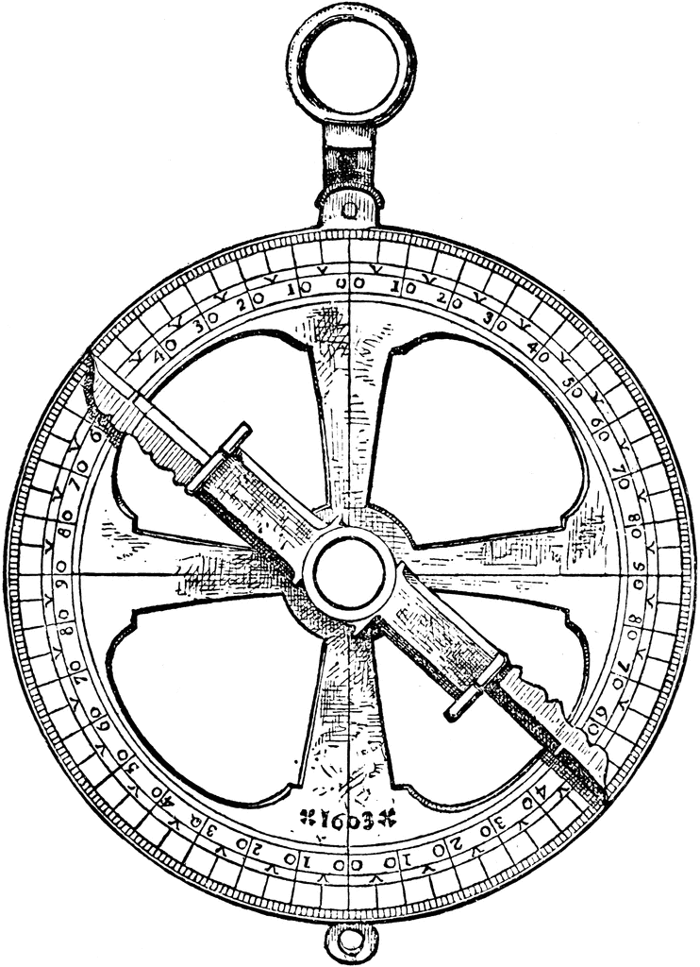
How did this improve trade?

Identify | 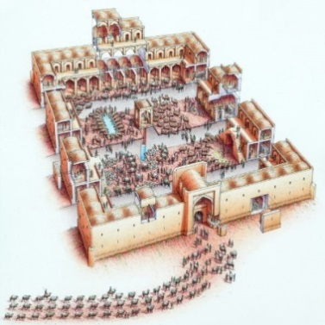
How did this improve trade?

Identify | 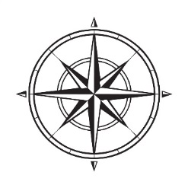
How did this improve trade?

Identify | 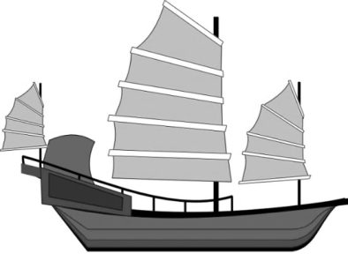
How did this improve trade?

- In the space below, explain how each of the following state practices facilitated commercial growth:

Inca Road System

Trade Organizations
(Hanseatic League)

Commercial Infrastructure
(Grand Canal of China)

Paper Money and Coin Minting | Allowed for easier transactions and to have a standard of what a product is worth; accepted by multiple locations

- The expansion of empires facilitated Afro-Eurasian trade and communication. On the map, label where each of these empires were located:
China (Sui, Tang, Song) Byzantine Empire Islamic Caliphates Mongol Empire
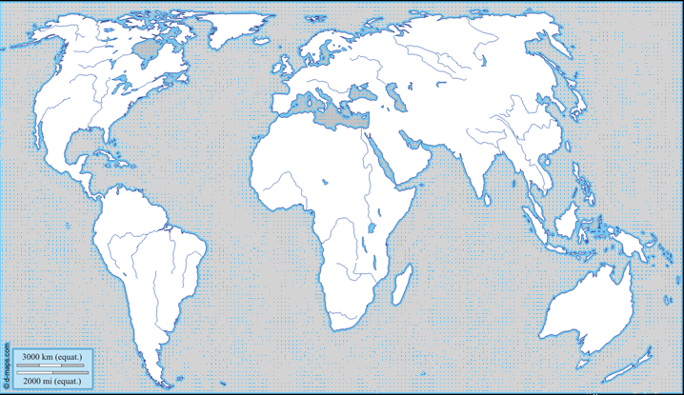

What are a few reasons why empires facilitated trade networks? ______________________________________________
__________________________________________________________________________________________________________________________________________________________________________________________________________________________________________________________________________________________________________________________________________________________________________________________________________________________________________________________________________________________________________
- The movement of peoples caused environmental and linguistic effects.

- The expansion and intensification of long-distance trade routes often depended on environmental knowledge and technological adaptations to it. Complete the chart below about these environmental/technological adaptations:

*Options for Adaptation: use of camels, use of horses, creation/use of longships
Group | Adaptation* | What did it allow them to do?
Scandinavian Vikings
Arabs and Berbers
Central Asian pastoral groups

- Some migrations had a significant environmental impact.
- Bantu migration and their transmission of iron technologies and agricultural techniques in Sub-Saharan Africa
- Polynesian migration and the spread of food and domesticated animals to new islands

- Some migrations and commercial contacts led to the diffusion of languages throughout a new region or the emergence of new languages.

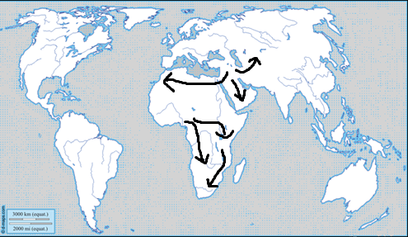
On the map, label the following
spread of languages:
- Bantu languages
- Turkic and Arabic languages

- Cross-cultural exchanges were fostered by the intensification of existing, or the creation of new, networks of trade and communication.

- Complete the grid below to identify the key facets of the Islamic religion:
ISLAM
Theism (mono, poly, etc) |  | Key God
Relative Location |  | Key Figures/Prophets
Approx. Founding |  | Moral Philosophy
Religious Text(s)

Explain how the following religions influenced the development of the Islamic faith:
Christianity

Judaism/Hebrew Peoples

Islam spread through military expansion, merchants/trade systems, and missionaries.

- In the space below, explain how the diasporic community introduced their culture into that of the indigenous peoples:
Muslim merchant communities in the Indian Ocean region

- As exchange networks intensified, an increased number of travelers within Afro-Eurasia wrote about their travels. Their writings illustrate both the extent and the limitations of intercultural knowledge and understanding.

Complete the following chart in order to compare the travelers:
 | Travel Dates | Origin | Religion | Findings
Ibn Battuta | 1325 – c.1353 | Tangier, Morocco | Muslim
Marco Polo | 1271 – 1295 | Venice, Italy | Christian

Draw the starting points and routes taken by Battuta and Polo on the map below. Be sure to use different colors or label each man’s routes.
- Increased cross-cultural interactions resulted in the diffusion of literary, artistic, and cultural traditions as well as scientific and technological innovations.

On the map above, illustrate the following:
- Spread of Christianity through Europe
- Spread of Hinduism and Buddhism into Southeast Asia
- Spread of Islam in Sub-Saharan Africa and Asia
- Spread of printing and gunpowder from East Asia to the Islamic empires and Western Europe

What were some effects of the spread of printing? _________________________________________________________
__________________________________________________________________________________________________
What were some effects of the spread of gunpowder? _______________________________________________________
__________________________________________________________________________________________________
- There was continued diffusion of crops and diseases like the Bubonic Plague throughout the Eastern Hemisphere along the trade routes.
- Bananas in Africa, New rice varieties in East Asia, Cotton, sugar, citrus throughout Dar al-Islam and Mediterranean basin
What was a negative effect of the spread of the plague? | What was a positive effect of the spread of the plague?

Key Concept 3.2 Continuity and Innovation of State Forms and Their Interactions

- Empires collapsed and were reconstituted; in some regions new state forms emerged.

- For each of the empires listed that collapsed, and then later reconstituted itself, identify and explain one traditional source of power they drew from and one innovation they used that was better suited to their specific local context.
(Options: patriarchy, religion, land-owning elites) (Options: new taxation methods, tributary systems, adaptation of religious institutions)
 | Traditional Source of Power/Legitimacy | Innovative Source of Power/Legitimacy
Byzantine Empire
Tang Dynasty
Song Dynasty

- In the space below, identify an Islamic state, Mongol Khanate, and decentralized form of feudalism that developed a new form of governance. Explain how each location’s government changed.
Islamic State:
Abbasids or Delhi Sultanate

Mongol Khanate:

City State 1 (Americas)

City State 2 (East Africa)

Decentralized Feudalism (Europe or Japan):

- Some states synthesized local and foreign traditions such as Persian traditions influencing the Islamic states or Chinese traditions that influenced states in Japan.

- Complete the following charts about the Americas:
MAYAN CITY-STATE
Relative Location | Southern Mexico and Yucatan Peninsula, northern Central America | Approx. Founding | 1800 BCE  Classic Period: 250 – 900 CE
Political/Economic Characteristics  (Leaders, Gov’t Style, Labor System, Trade, etc.) |  | Religious System  (Gods, Texts, Belief Characteristics, etc.)
Leaders claimed divine authority  Society mostly based on agriculture |  | Polytheistic (God of sun, moon, rain, corn)  Performed torture and human sacrifice rituals to please the gods
Technological Innovations |  | Artistic/Scientific Innovations
Creation and use of paper |  | Creation of pyramids  Use of zero in math  Highly accurate 365 day calendar  Stone carvings in buildings and monuments
MEXICA/AZTECS
Relative Location |  | Approx. Founding
Political/Economic Characteristics  (Leaders, Gov’t Style, Labor System, Trade, etc.) |  | Religious System  (Gods, Texts, Belief Characteristics, etc.)
Technological Innovations |  | Artistic/Scientific Innovations

INCA
Relative Location |  | Approx. Founding
Political/Economic Characteristics  (Leaders, Gov’t Style, Labor System, Trade, etc.) |  | Religious System  (Gods, Texts, Belief Characteristics, etc.)
Technological Innovations |  | Artistic/Scientific Innovations

- For each of the areas below where interregional conflict and contact occurred, identify technological and cultural transfers: (Options: gunpowder, paper-making techniques, Neoconfucianism, Christianity)
Technological & Cultural Transfers

Conflict between Tang China and
the Abbasids
Mongol empires
The Crusades
Chinese maritime activity led by
Ming Admiral Zheng He

Key Concept 3.3 Increased Economic Productive Capacity and Its Consequences

- Innovations stimulated agricultural and industrial production in many regions.

- Complete the following charts about technological innovations that significantly increased agricultural production: (Options: chinampas, terrace farming)
Identify | 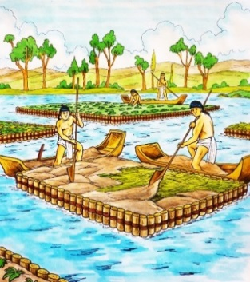
What type of environment/landscape was this used in?

How did this improve agricultural production?

Identify | 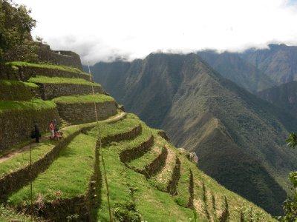
What type of environment/landscape was this used in?

How did this improve agricultural production?

- What factors caused Chinese, Persian, and Indian artisans and merchants to expand their production of textiles and porcelain for export?
____________________________________________________________________________________________________________________________________________________________________________________________________
What factors caused China to expand the industrial production of iron and steel during this period?
______________________________________________________________________________________________________________________________________________________________________________________________________________________________________________________________________________________________________
- The fate of cities varied greatly, with periods of significant decline, and with periods of increased urbanization maintained by rising productivity and expanding trade networks.

- Identify and explain THREE causes of urban decline during this period:
Factors: | Explain how this factor caused urban decline:
Invasions
Disease
Decline of Agricultural Productivity

- Identify and explain THREE factors that led to urban revival during this period:
Factors: | Explain how this factor encouraged urban revival
Greater Availability of Labor
Availability of Safe and Reliable Transportation
Rise of Commerce

- Despite significant continuities in social structures and in methods of production, there were also some important changes in labor management and in the effect of religious conversion on gender relations and family life.

- Explain each of the forms of labor organization that occurred during this period:
Free Peasant Agriculture
Nomadic Pastoralism
Craft Production and
Guild Organization
Coerced and Unfree Labor
Government-imposed Labor Practices
Military Obligations

- For each of the civilizations listed below, explain how despite the persistence of patriarchy, women exercised more power and influence than in previous periods:
Mongol Empire
West Africa
Japan
Southeast Asia
- In the space below, explain the role of serfdom in Japan and Europe and the expansion of the mit’a system in the Inca Empire:
European Serfdom
Japanese Serfdom
Incan Mit’a System

Identify and explain ONE instance of free peasants resisting attempts to raise dues and taxes by staging a revolt:
______________________________________________________________________________________________________________________________________________________________________________________________________________________________________________________________________________________________________
Explain why the regions listed below had an increased demand for slaves:
Eastern Mediterranean
Central Eurasia
Incan Mit’a System

- The diffusion of Buddhism, Christianity, Islam, and Neoconfucianism often led to significant changes in gender relations and family structure.

Identify and explain foot binding, including where it was practiced why it was practiced.
______________________________________________________________________________________________________________________________________________________________________________________________________________________________________________________________________________________________________

